

SOUTH EAST ASIAN INSTITUTE OF TECHNOLOGY, INC.

National Highway, Crossing Rubber, Tupi, South Cotabato

**COLLEGE OF INFORMATION AND COMMUNICATION TECHNOLOGY**

___________________________________________________

**LEARNING MODULE**

**FOR**

**IT 123: WEB DEVELOPMENT 1**

**_____________________________________________________**

***WEEK 9***

**COURSE OUTLINE**

**COURSE CODE**  : IT 123

**TITLE**  : Web Development 1

**TARGET POPULATION** : All BS Information Technology Students

**INSTRUCTOR** : MS. CAROL KATE M. ESTACIO

**Overview:**

HTML stands for Hypertext Markup Language, and it is the most widely used language to write Web Pages.

• Hypertext refers to the way in which Web pages (HTML documents) are linked together. Thus, the link available on a webpage is called Hypertext.

• As its name suggests, HTML is a Markup Language which means you use HTML to simply "mark-up" a text document with tags that tell a Web browser how to structure it to display.

Originally, HTML was developed with the intent of defining the structure of documents like headings, paragraphs, lists, and so forth to facilitate the sharing of scientific information between researchers.

Now, HTML is being widely used to format web pages with the help of different tags available in HTML language.

**Content:**

**HTML Multimedia**

* + **HTML Media**
  + **HTML Video & Audio**

**Objectives:**

General Objective

* + To know and understand the usage of <video> and <audio> element.
  + To know how to add videos and audio on your website.

**Instruction to the Learner**

Each chapter in this module contains a major lesson involving the basics of Web page coding and HTML editing tool. The units are characterized by continuity, and are arranged in such a manner that the present unit is related to the next unit. For this reason, you are advised to read this module. After each unit, there are exercises to be given. Submission of task given will be every Monday during your scheduled class hour.

**HTML Media**

Multimedia comes in many different formats. It can be almost anything you can hear or see. Examples: Pictures, music, sound, videos, records, films, animations, and more. Web pages often contain multimedia elements of different types and formats. Multimedia files are recognized by the following extensions:

|  |  |  |
| --- | --- | --- |
| Format | File | Description |
| MPEG | .mpg .mpeg | MPEG. Developed by the Moving Pictures Expert Group. The first popular video format on the web. Used to be supported by all browsers, but it is not supported in HTML5 (See MP4). |
| AVI | .avi | AVI (Audio Video Interleave). Developed by Microsoft. Commonly used in video cameras and TV hardware. Plays well on Windows computers, but not in web browsers. |
| WMV | .wmv | WMV (Windows Media Video). Developed by Microsoft. Commonly used in video cameras and TV hardware. Plays well on Windows computers, but not in web browsers. |
| QuickTime | .mov | QuickTime. Developed by Apple. Commonly used in video cameras and TV hardware. Plays well on Apple computers, but not in web browsers. (See MP4) |
| RealVideo | .rm .ram | RealVideo. Developed by Real Media to allow video streaming with low bandwidths. It is still used for online video and Internet TV, but does not play in web browsers. |
| Flash | .swf .flv | Flash. Developed by Macromedia. Often requires an extra component (plug-in) to play in web browsers. |
| Ogg | .ogg | Theora Ogg. Developed by the Xiph.Org Foundation. Supported by HTML5. |
| WebM | .webm | WebM. Developed by the web giants, Mozilla, Opera, Adobe, and Google. Supported by HTML5. |
| MPEG-4 or MP4 | .mp4 | MP4. Developed by the Moving Pictures Expert Group. Based on QuickTime. Commonly used in newer video cameras and TV hardware. Supported by all HTML5 browsers. Recommended by YouTube. |

*Note: only MP$, WebM, and Ogg video are supported by the newest HTML5 standard.*

If your website is about recorded music, MP3 is the choice. The following are the different sound formats:

|  |  |  |
| --- | --- | --- |
| Format | File | Description |
| MIDI | .mid .midi | MIDI (Musical Instrument Digital Interface). Main format for all electronic music devices like synthesizers and PC sound cards. MIDI files do not contain sound, but digital notes that can be played by electronics. Plays well on all computers and music hardware, but not in web browsers. |
| RealAudio | .rm .ram | RealAudio. Developed by Real Media to allow streaming of audio with low bandwidths. Does not play in web browsers. |
| WMA | .wma | WMA (Windows Media Audio). Developed by Microsoft. Commonly used in music players. Plays well on Windows computers, but not in web browsers. |
| ACC | .aac | AAC (Advanced Audio Coding). Developed by Apple as the default format for iTunes. Plays well on Apple computers, but not in web browsers. |
| WAV | .wav | WAV. Developed by IBM and Microsoft. Plays well on Windows, Macintosh, and Linux operating systems. Supported by HTML5. |
| Ogg | .ogg | Ogg. Developed by the Xiph.Org Foundation. Supported by HTML5. |
| MP3 | .mp3 | MP3 files are actually the sound part of MPEG files. MP3 is the most popular format for music players. Combines good compression (small files) with high quality. Supported by all browsers. |
| MP4 | .mp4 | MP4 is a video format, but can also be used for audio. MP4 video is the upcoming video format on the internet. This leads to automatic support for MP4 audio by all browsers. |

*Note: Only MP3, WAV, and Ogg audio are supported by the newest HTML5 Standard.*

***HTML Video – Browser Support***

|  |  |  |  |
| --- | --- | --- | --- |
| Browser | MP4 | WebM | Ogg |
| Internet Explorer | YES | NO | NO |
| Chrome | YES | YES | YES |
| Firefox | YES | YES | YES |
| Safari | YES | NO | NO |
| Opera | YES (from opera 25) | YES | YES |

**HTML Video Tags**

|  |  |
| --- | --- |
| Tag | Description |
| <video> | Defines a video or movie |
| <source> | Defines multiple media resources for media elements, such as <video> and <audio> |
| <track> | Defines text tracks in media players |

**HTML Video Element**

***<video>***

To show a video in HTML, use the <video> element:

Example

<!DOCTYPE html>  
<html>

<head>

</head>  
<body>

<video width="320" height="240" controls>  
   <source src="movie.mp4" type="video/mp4">  
   <source src="movie.ogg" type="video/ogg">  
Your browser does not support the video tag.  
</video>

<body>  
</html>

The **controls** attribute adds video controls, like play, pause, and volume. It is a good idea to always include **width** and **height** attributes. If height and width are not set, the browser does not know the size of the video. The effect will be that the page will change (or flicker) while the video loads. Text between the **<video>** and **</video>** tags will only display in browsers that do not support the <video> element. Multiple **<source>** elements can link to different video files. The browser will use the first recognized format.

**HTML Video Auto play**

To start a video automatically use the **autoplay** attribute:

Example

<!DOCTYPE html>  
<html>

<head>

</head>  
<body>

<video width="320" height="240" autoplay>  
   <source src="movie.mp4" type="video/mp4">  
   <source src="movie.ogg" type="video/ogg">  
Your browser does not support the video tag.  
</video>

<body>  
</html>

**HTML Audio Tags**

|  |  |
| --- | --- |
| Tag | Description |
| <audio> | Defines sound content |
| <source> | Defines multiple media resources for media elements, such as <video> and <audio> |

**HTML Audio Element**

To play an audio file in HTML, use the **<audio>** element:

Example

<!DOCTYPE html>  
<html>

<head>

</head>  
<body>

<<audio controls>  
  <source src="horse.ogg" type="audio/ogg">  
  <source src="horse.mp3" type="audio/mpeg">  
Your browser does not support the audio element.  
</audio>

<body>  
</html>

HTML Audio – Browser Support

|  |  |  |  |
| --- | --- | --- | --- |
| Browser | MP4 | WebM | Ogg |
| Internet Explorer | YES | NO | NO |
| Chrome | YES | YES | YES |
| Firefox | YES | YES | YES |
| Safari | YES | YES | NO |
| Opera | YES | YES | YES |

**Review Questions**

1. Briefly discuss the Multimedia Formats.
2. What are the new tags in media elements in HTML?
3. What video and audio formats are used for embedding on web page?
4. How to embed video and audio in HTML?
5. What are the two ways to specify the height and width of multimedia files embedded with the object tag?

**Test Yourself**

1. Create a HTML file containing an example video and additional text on it.

***Sample output:***

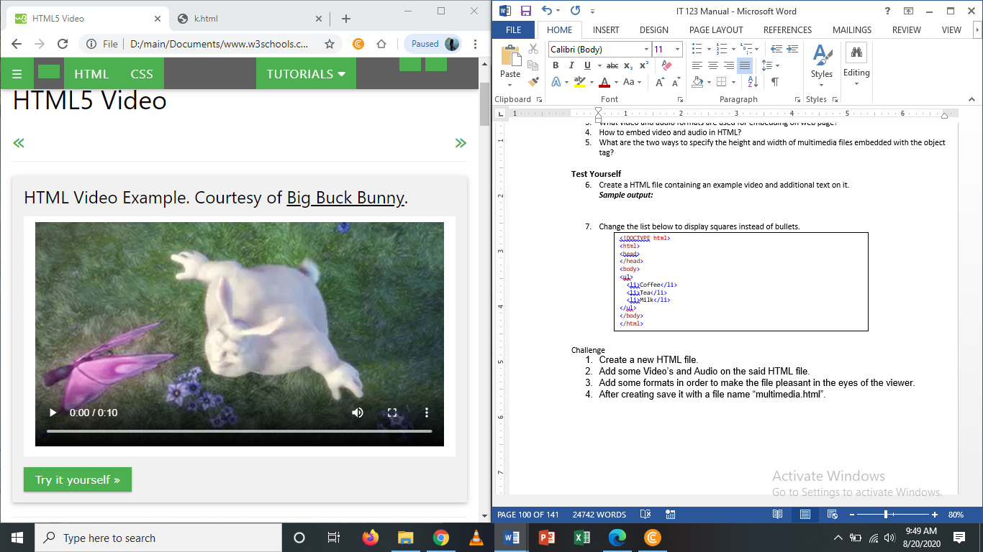

1. On the video file that you created change the attribute to auto play and adjust its height and width.

**Challenge**

1. Create a new HTML file.
2. Add some Video’s and Audio on the said HTML file.
3. Add some formats in order to make the file pleasant in the eyes of the viewer.
4. After creating save it with a file name “multimedia.html”.